1. You need to install the following application.
   1. Xampp: <https://www.apachefriends.org/index.html>

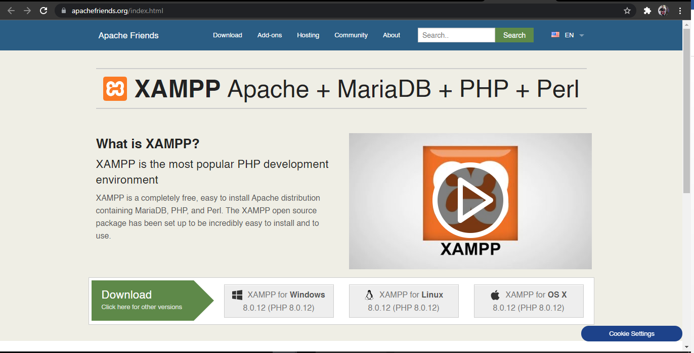

* 1. 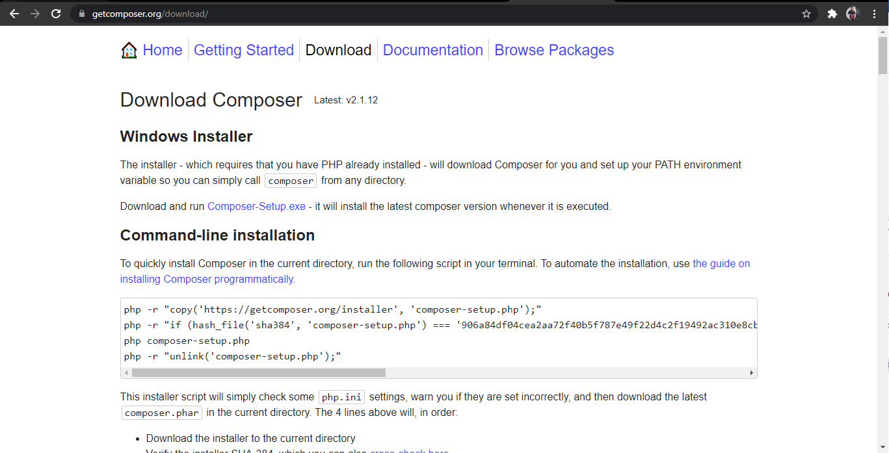Composer: <https://getcomposer.org/download/>

1. Go to xampp>php; Open with notepad, notepad++ or vs code the php.ini.

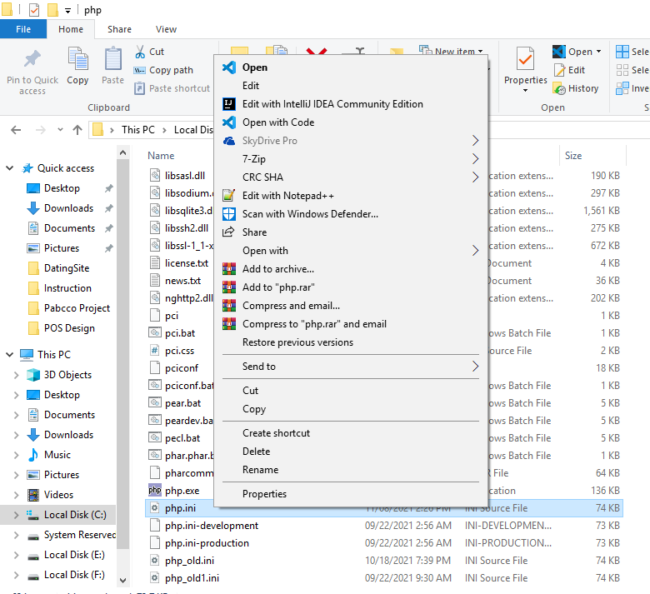

1. Add “extension=intl” in the php.ini.

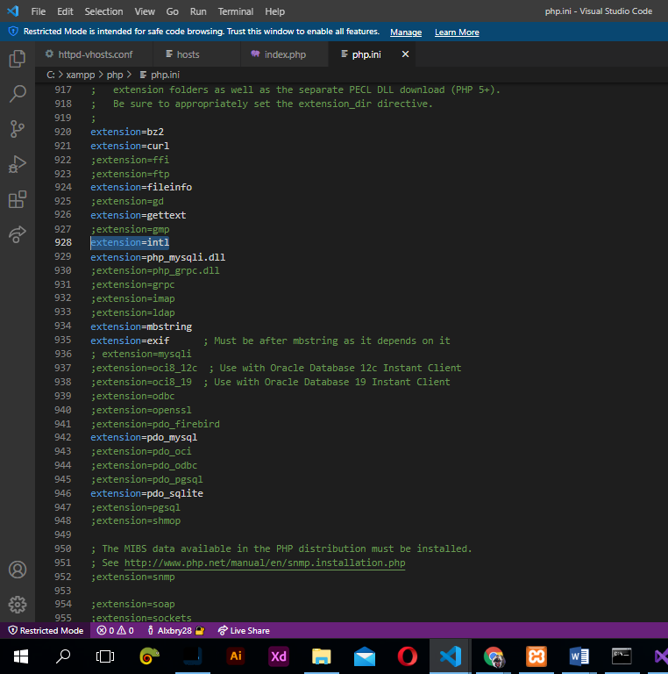

1. Move the source code folder to C://xampp/htdocs and open the command line or command prompt and set the path into that folder. Type “composer install” in the command prompt to install the php libraries.

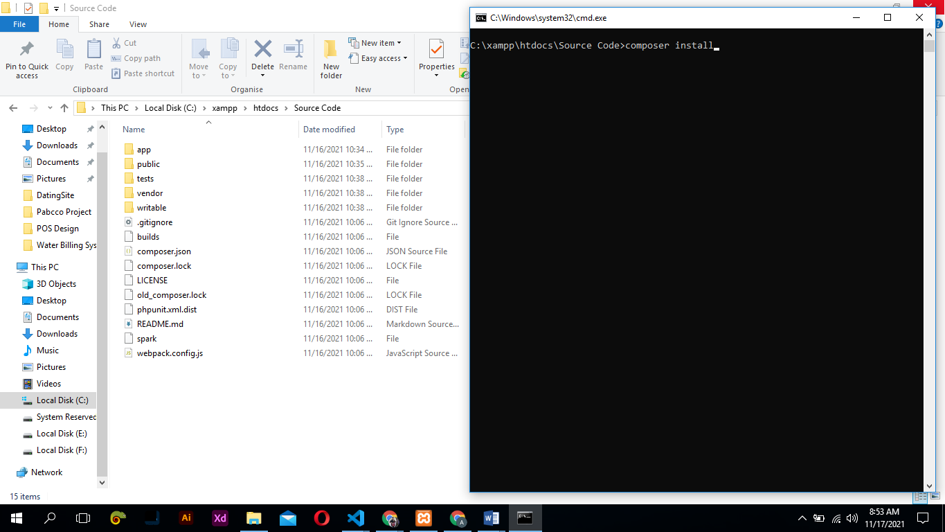

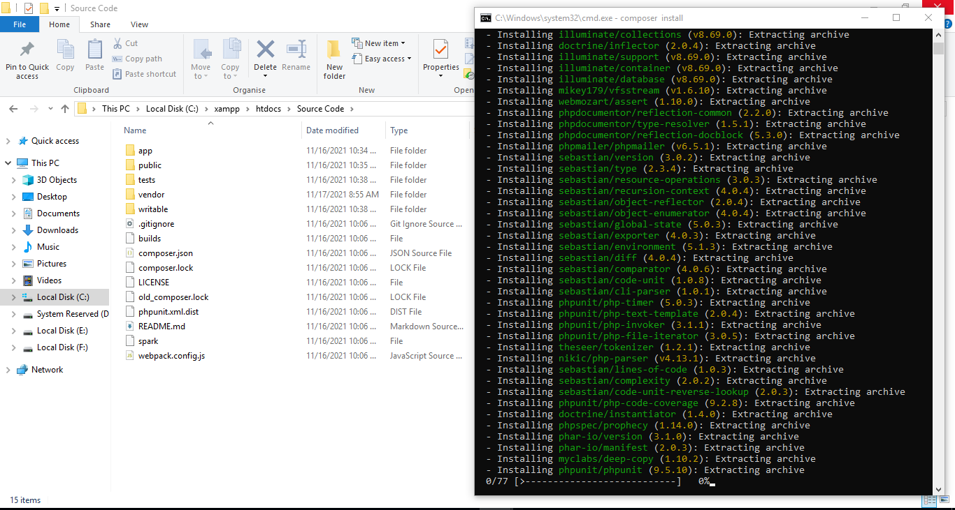

1. Open with VS code the folder Source Code. Rename the old.env, leave it as .env

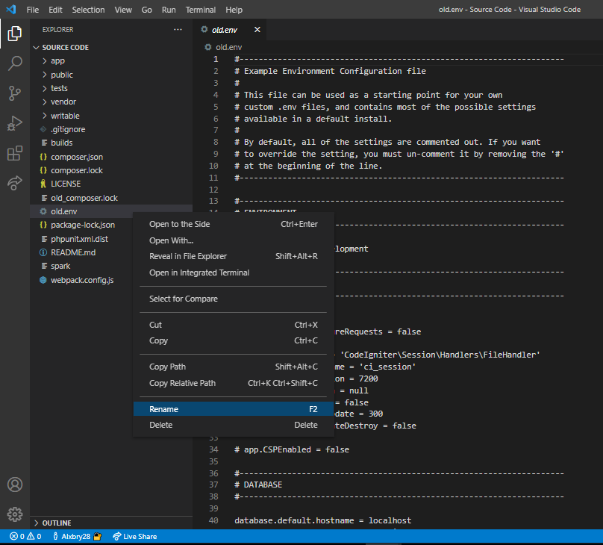

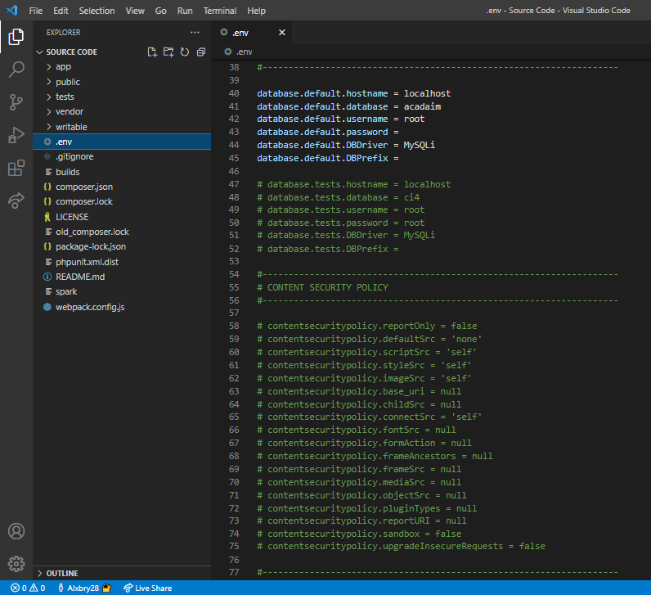

1. Set the path to public in the command prompt

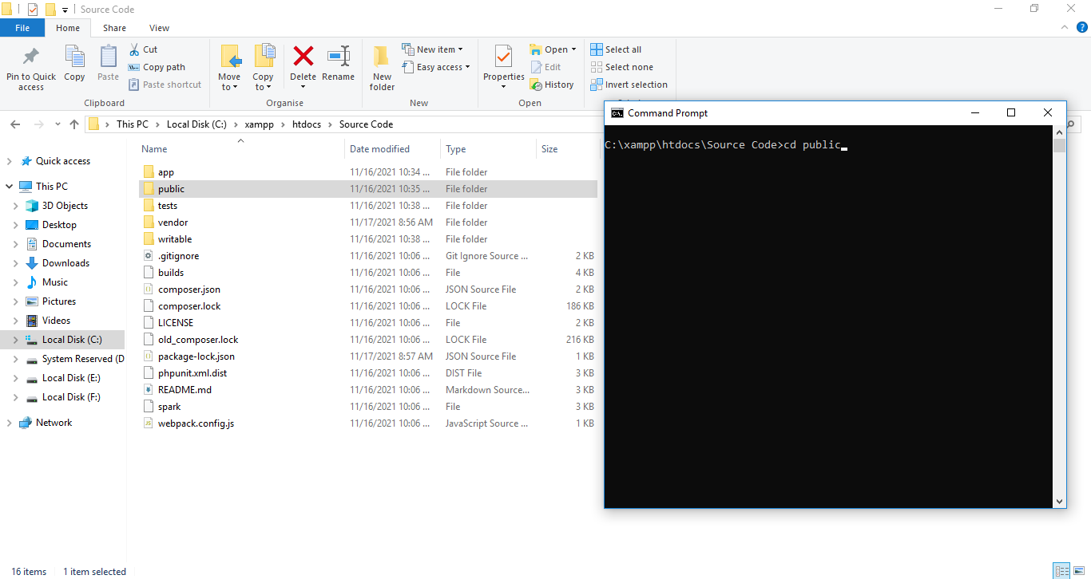

1. 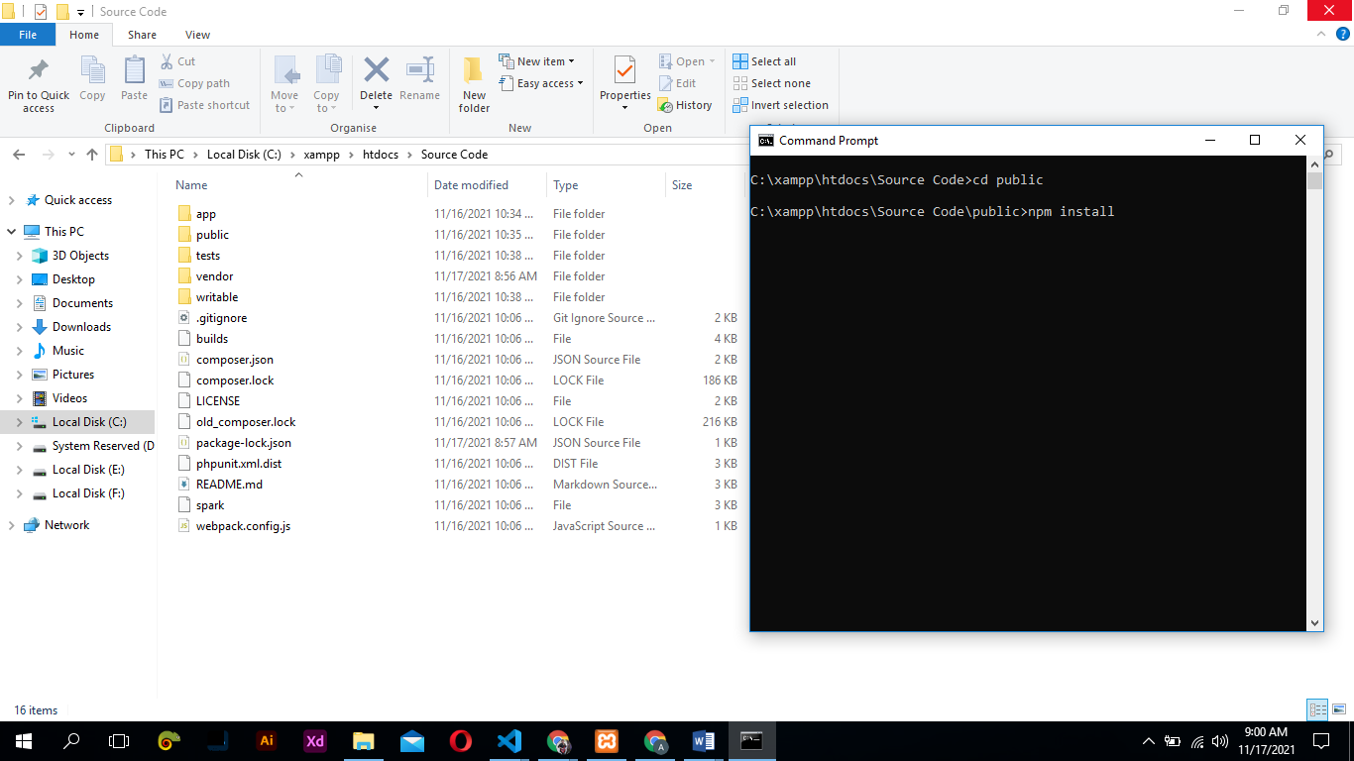Type “npm install” in the command prompt.
2. Go to Xampp>Apache>conf>extra; Open with notepad, notepad++ or vs code. Edit the httpd-vhosts.conf.

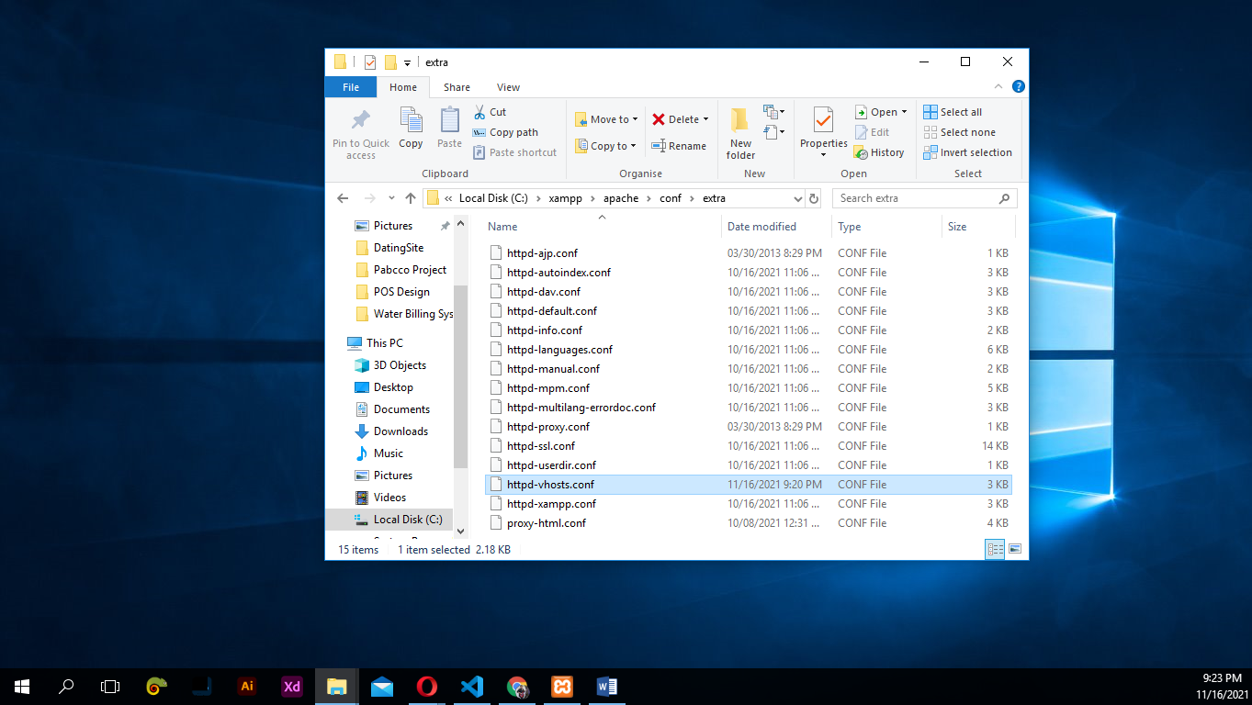

Type the the path of public folder from source code folder to add the project file for virtual host.

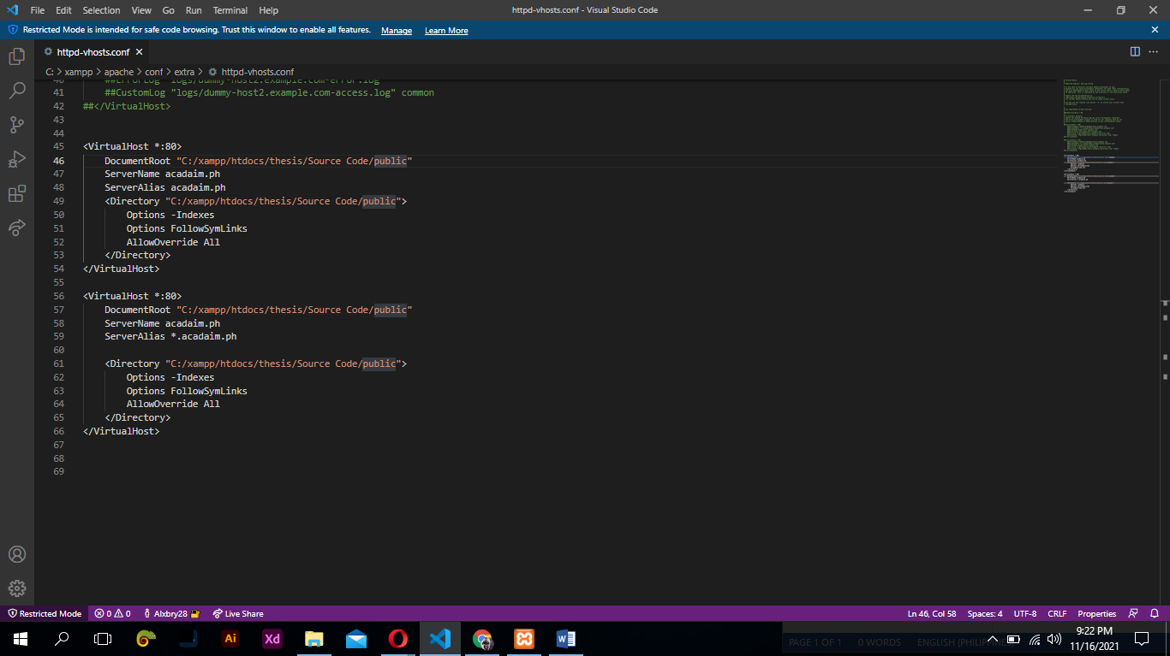

1. Go to Windows>System32>drivers>etc; Open with notepad, notepad++ or vs code. Edit the host.

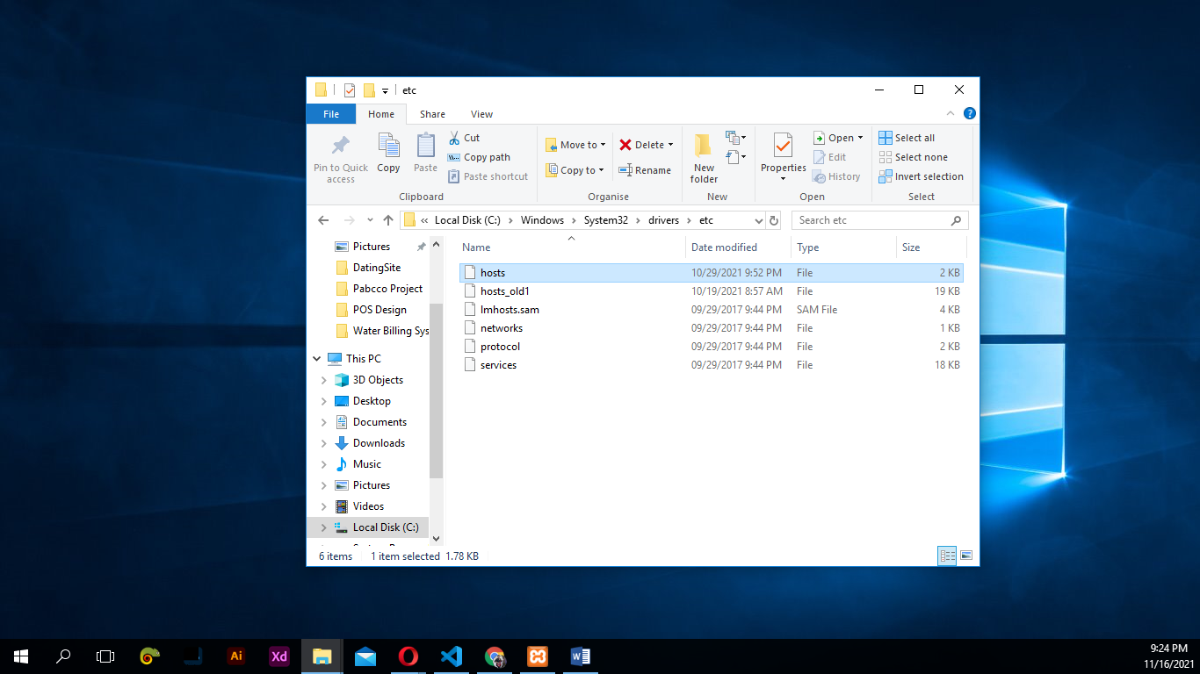

Add the following to the file. It will create a virtual domain for our localhost.

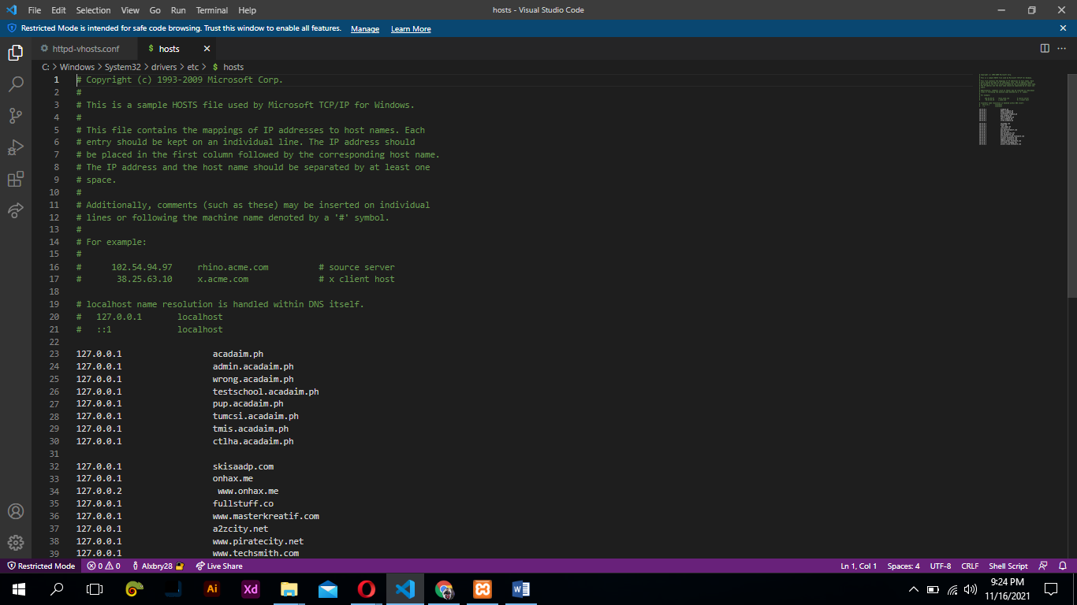

1. Start the xampp control panel, then start the apache and mysql. Allow the access of apache and mysql.

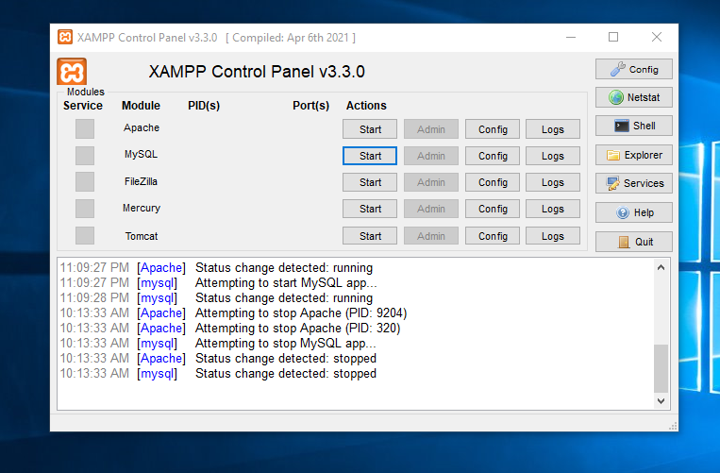

After the start, click the admin button of MySQL.

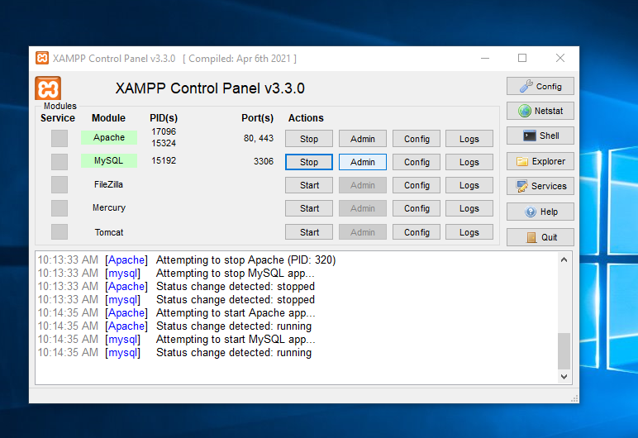

1. Create a new database named “acadaim”

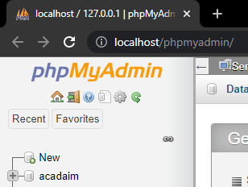

1. Click the import, choose the acadaim.sql from the database folder. Then press Go.

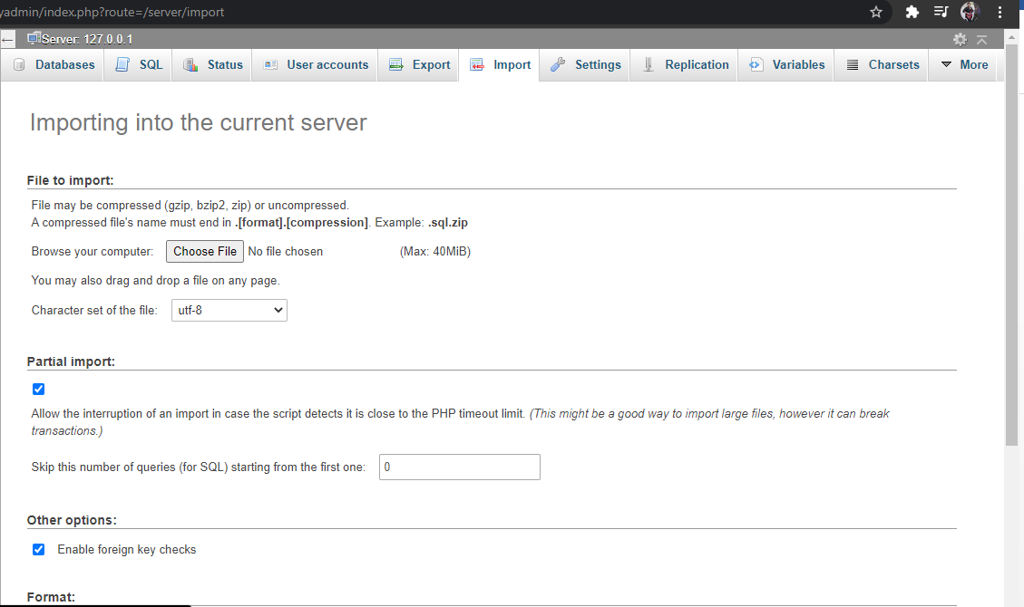

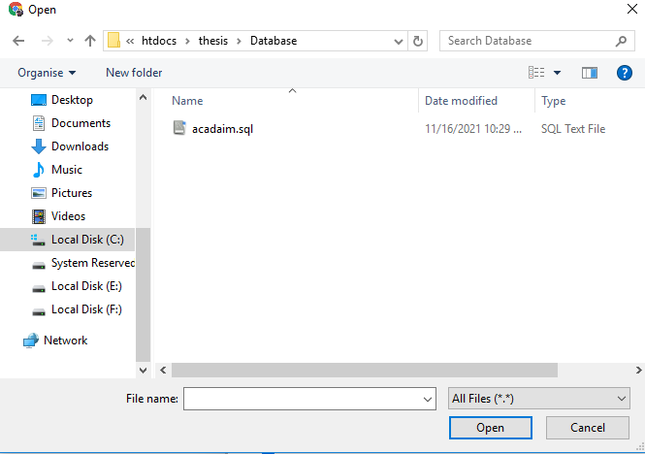

1. Open your browser, open <http://acadaim.ph>

